**HOMEWORK #5 – 1901042694**

Student ID 1901042694

Student Name Muhammet Çağrı

Student Surname Yılmaz

First of all, I want to mention about homework briefly. In this homework we have 3 games and we derived class from base class for each game. The base class are called BoardGame2D.

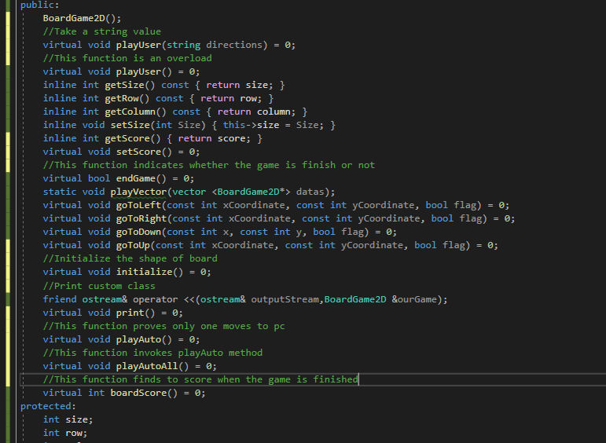

As I said before we have 3 games. These games are 8-Puzzle, Peg Solitaire, Klotski Game.

When we want to create a class we will inherit this abstract class.

**8-Puzzle**

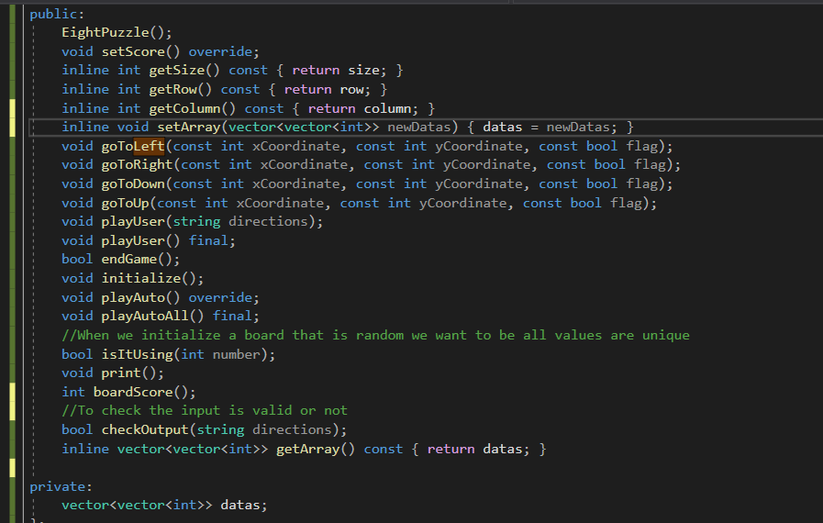

These are our methods and data and All games can play user or computer.

Let’s assume user plays the game

I have a check function that checks the input

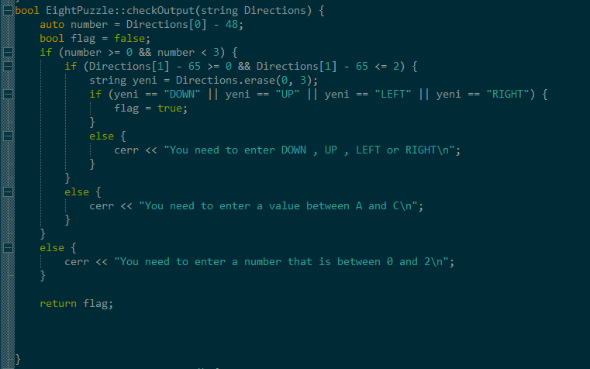

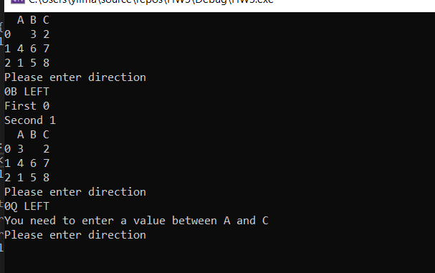

If computer plays the game It will be shown like this: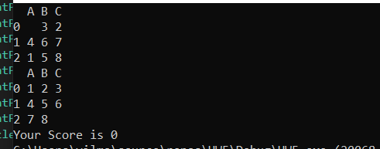

İf the score is 0 it means that you finished game successfully.

Now I am going to deal PegSolitaire Game.

**PegSolitaire**

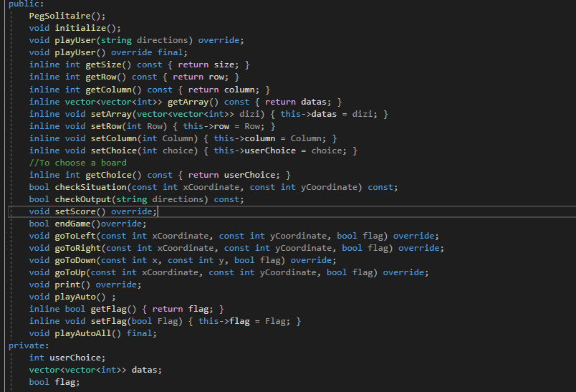

**This is our pegSolitaire class that derived from baseClass**

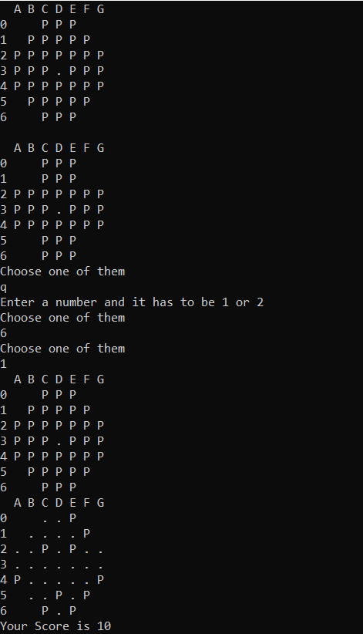

If user plays, it will show like this:

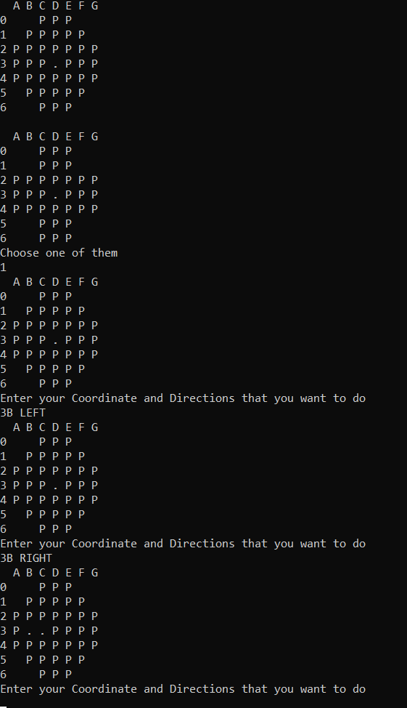

**Klotski Game**

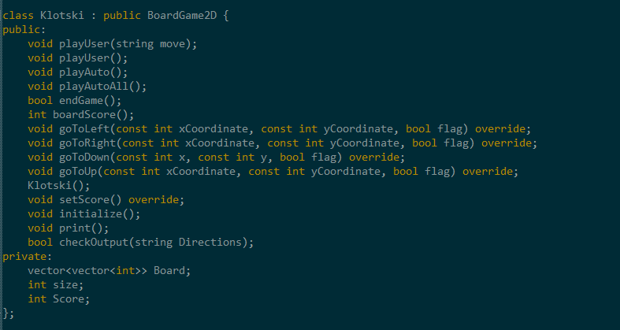

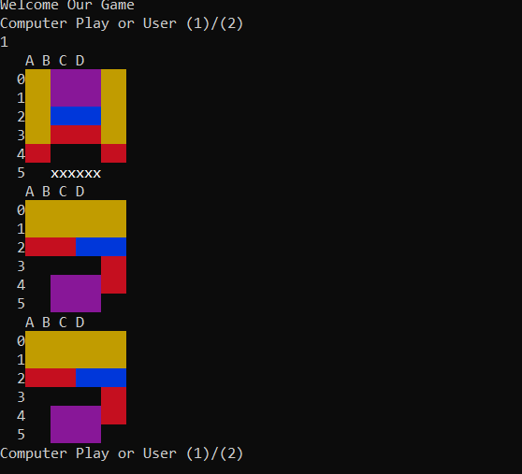

It will be shown like this

And I have a test function that calls playVector and it prints out score whole vector

